**Information System Management Lab**

**BCOM 307**

**Assignment #27**

***Submitted by:***

**Name:** YASH JAIN

**Enrollment No:** 03914788818

**Semester:** B.Com(H) 5TH Semester

**Class:** B.COM(H)

**Section:** B.Com 5A

**Date of Submission:** 14/11/2021

***Submitted to:***

**Praveen Kumar Singh**

**Assistant Professor, MAIMS**



**Department of Commerce**

**Maharaja Agrasen Institute of Management Studies**

**Affiliated to Guru Gobind Singh Indraprastha University, Delhi**

**Sector -22, Rohini, Delhi -110086, India; www.maims.ac.in**

Maharaja Agrasen Institute of Management Studies

Affiliated to GGS IP University; Recognized u/s 2(f) of UGC Recognized by Bar Council of India; ISO 9001: 2015

Certified Institution Sector 22, Rohini, Delhi -110086, India; [www.maims.ac.in](http://www.maims.ac.in/)

Department of Commerce

Academic Year: 2020-21

Semester: Vth

# Assignment No. 27

# Unit No:

**Course/Subject Code:** BCOM 307 **Subject Title: Information System Management Lab**

# Issue Date Last Date of Submission:

**Instructions for Students:**

# All Questions are Compulsory.

1. The student should attach proper cover page for each assignment clearly mentioning the Assignment No.
2. Each assignment should be prepared by the student individually with proper explaination and screenshots.
3. A4 size ruled sheets should be used for the assignment.
4. Assignment pages should be serially numbered at the bottom of page.

***During online education mode, upload scanned copy of the complete assignment including cover page latest by due date.***

|  |  |  |
| --- | --- | --- |
| **Question No.** | **Question** | **CO No.** |
| 1 | List the clients who are located in Mumbai. | **CO2, CO3, CO4, CO5** |
| 2 | Change the city of client_no C0001 to bangalore. |
| 3 | Change the cost price of jeans to rs. 950. |
| 4 | Add a column called telephone of datatype INT to clients table. |
| 5 | Change the name of salesman table to sales_master. |
| 6 | Listing of products whose selling price is more than 500 with the new selling price calculated as original selling price + 15%. |
| 7 | Count the no of products having price>500. |
| 8 | Find all products whose qty_on_hand is more than reorder level. | **CO2, CO3, CO4, CO5** |
| 9 | Determining the maximum and minimum price for the product prices. |
| 10 | List the clients who are located in state ending with ‘a’. |

**ASSIGNMENT 27 - REVISION OF CONCEPTS**

**Task 1 : List the clients who are located in Mumbai.**

This task can be completed using the **WHERE** Clause.

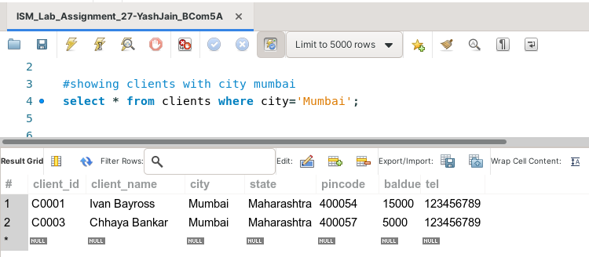

**Task 2: Change the city of client_no C0001 to Bangalore.**

This task can be completed using the **UPDATE** Keyword.

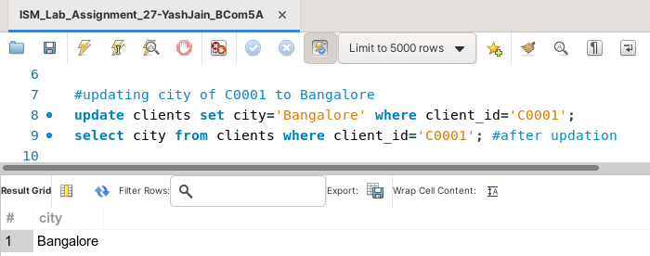

**Task 3: Change the cost price of jeans to Rs. 950.**

This task can be completed using the **UPDATE** Keyword.

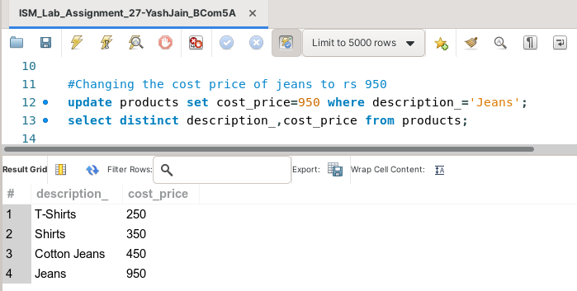

**Task 4: Add a column called telephone of datatype INT to clients table.**

This task can be completed using the **ALTER TABLE** Command, along with the **ADD COLUMN** Keyword.

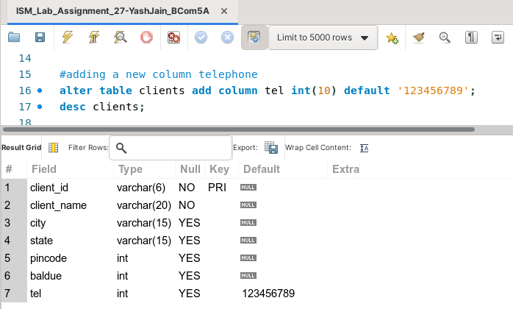

**Task 5: Change the name of salesman table to sales_master.**

This task can be completed using the **RENAME** Command.

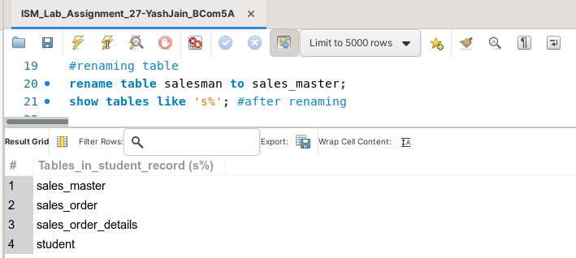

**Task 6: Listing of products whose selling price is more than 500 with the new selling price calculated as original selling price + 15%.**

This task can be completed using the **WHERE** Clause**.**

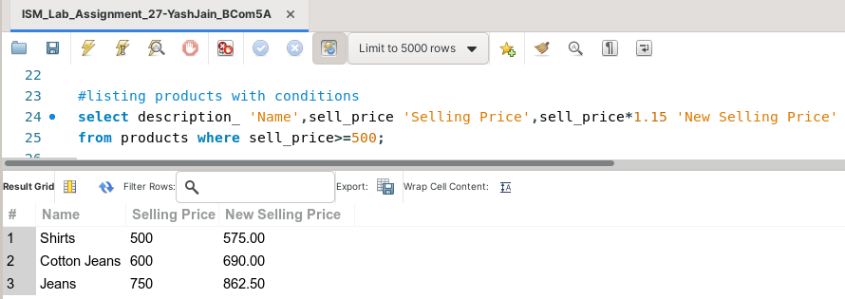

**Task 7: Count the no of products having price>500.**

This task can be completed using the **COUNT( )** Aggregate function.

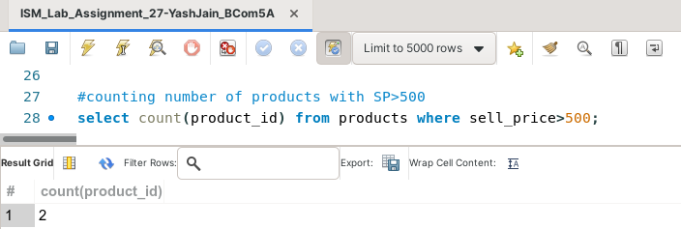

**Task 8: Find all products whose qty_on_hand is more than reorder level.**

This task can be completed using the **WHERE** clause.

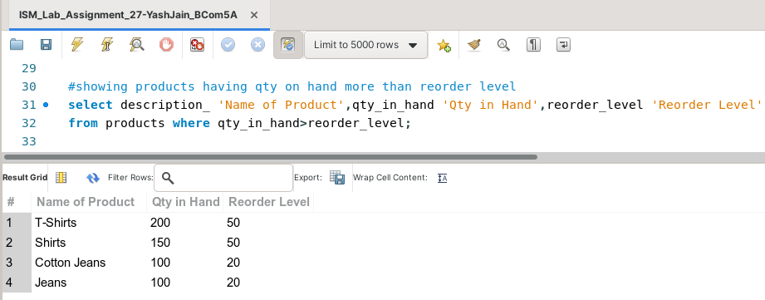

**Task 9: Determining the maximum and minimum price for the product prices.**

This task can be completed using the **MAX( )** and **MIN( )** Aggregate Functions.

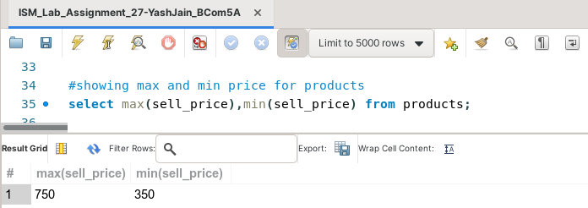

**Task 10: Display the employee records of employees hired in April 2013.**

This task can be completed using the **LIKE** predicate, along with the % (percentage) symbol**.**

